GRADE 8 PRE- TECHNICAL STUDIES RATIONALIZED LESSON NOTES

STRAND 1: FOUNDATION OF PRETECHNICAL STUDIES
1.1 FIRE AND DATA SAFETY
Importance of safety in a work environment.
- Reduces financial losses needed to repair damaged property.
- Increases business rating because of customer and worker satisfaction.
- Reduces job losses that comes from permanent injuries.
- Reduces financial losses needed for medical expenses.
- Reduces damage to property because of lower number of accidents at workplaces.  Reduces cases of injury because of lower number of accidents at workplaces.  It improves productivity.

Causes of fire in a work environment.
- Some of the possible causes of fire outbreak in the work environment include:
- Faulty equipment such as extension cables in places such as kitchens, offices, workshop or warehouses.
- Fires when performing tasks such as welding, flame cutting or grinding. This work generates heat, sparks or flames to cause fire.
- Improper storage of flammable and combustible materials such as flammable liquids or charcoal in workplace.
- Human errors such as using equipment such as electric cooker incorrectly, not reporting faulty machinery as well as leaving cooking food unattended may lead to fire accidents.

Injuries caused by fire at work places.
- Injuries caused by fire occurs when you get in contact with open fire or burning objects.
- Some of the injuries caused by fire in a work environment include:
- Burns-where fire raises temperature of the skin and tissues causing the tissues and cells to die.
- Smoke chocking- where the victim suffers obstructed breathing, seizures and comas.
- Chemical poisoning from inhaling poisonous fumes such as carbon monoxide. Shock where a victim develops abnormal heart rhythm and becomes unconscious.

Prevention of fire outbreaks in a work environment.
- Ways of preventing fire outbreak in the environment include:
- Providing enough safety and security at work premises.
- Keeping a work environment clean and orderly.
- Being cautious when performing activities using open fire.
- Having all equipment well services and maintained.
- Allowing for easy access to electrical switches and fire alarm equipment.
- Storing and handling flammable materials and liquids with care.

Types of fire injuries and their first aid requirements.
Different types of fire injuries require different First aid approaches.
The first aid for different fire injuries are as follows:
Performing First Aid for fire burns.
- Assess (find out) the situation to ascertain your own safety.
- Immediately get the person away from the heat sources to stop the burning.
- Cool the burn with cool or lukewarm running water for 20 minutes.
- Remove any clothing or jewellery that is near the burnt area of the skin. Do not move anything stuck to the skin.
- Make sure the person keeps warm using a warm cover such as blanket, but take care not to rub it against the burnt area.
- Cover the burn by placing a layer of cling film over it.
- If the injury is on the face, sit up as much as possible, rather than lying down. This helps to reduce swelling.

Performing First Aid for smoke choking.
- Remove casuality from smoke or toxic exposure to a safe and more ventilated open space.
- Sit casuality upright and loosen clothing around the neck and airways.
- If the casuality has breathing difficulties, call for assistance to take him or her to the hospital.

Performing First Aid for smoke poisoning.
- Move the casuality or victim to a safer place with fresh air if you can.
- Sit the person or lay them down on their side, not their back.
- If the victim has breathing difficulties, get emergency help to take him or her to hospital.

Performing First Aid for shock.
- Lay the person down, and if possible, elevate their feet about 30cm unless the head, neck or back is injured or you suspect broken hip or leg bones.
- Do not raise the person’s head or turn the person on the side if they are vomiting or bleeding from the mouth.
- Keep the person warm and comfortable.
- If the victim has breathing difficulties, get emergency help o take him or her to the hospital

Fire fighting methods at work environment.
There are four fire fighting methods applicable in a work environment. These are:
- Cooling method.
 This is where the temperature of the burning materials is reduced to slow down the burning.
 A suitable example is where cold water is used to put out a fire.

- Smothering method.
 This is where the supply of oxygen to the burning object is cut out to slow down the burning process.
 An example is covering a burning object with a fire blanket or sand.

- Starving method.
 This method involves the following activities:
    - Removing combustible items from the vicinity of the fire.
    - Removing the parts of the burning material from the mass of burning material. For example, removing a burning piece of wood from a large pile.

- Interrupting method.
 This is the use of chemical sprays that stops burning.
 An example is the use of foam and carbon dioxide fire extinguishers

Need for observing fire safety in the work environment.
The following are reasons why or importance of observing fire safety in the work environment:
  - To safeguard employee’s safety by teaching them about the devices that help in fire prevention, ways of handling fires, and how to safely exit buildings during fire outbreaks.
  - To keep organizations free from hazards which reduces loss of warehouse materials through fire outbreaks.
  - To increase productivity because a safe workplace has lower absenteeism, higher turnover and lower employee injury.
  - Protecting where items are sentimental and not easy to replace.

Data Safety in Electronic devices.
  - Electronic devices users should prioritise protecting data against loss.
  - Several control measures of securing data can be used.
  - Specific measures are designed to deal with specific data threats when using electronic devices such as computer.

- Data threats in a computer.
    - Data safety-it is protecting digital data from lose through safe storage and backing up.
    - Data privacy-is protecting personal information from unauthorised access.
It is also the ability of people to determine who can access their personal data.
    - Data threats- are any potential dangers to information stored in an electronic device or computer system. They include actions that may be internal or external and that may cause stealing, destruction, denying access to or loss of data.

Data threats are commonly caused by:
        - Hackers.
        - Malware or virus attacks.
        - Fraudsters.
        - Thieves.
        - Human errors.
        - Unauthorised access to files.
        - Malicious access to system functions by unauthorised persons.

- Way or measures for securing data in an electronic device such as computer.
      - Installation of antivirus software-helps to detect and delete malicious computer programs or virus that destroys data.
      - Backing up data – data can be retrieved after creating a copy of the data on your system which you can use for recovery in case original data is lost or corrupted.
      - Use of strong passwords -strong passwords prevents unauthorised access to data stored in electronic devices.
      - Regularly changing passwords.
      - Limiting personal information to share.

Control measure | What the measure protects the data against
Backing up data | Protects data from complete loss.
Installing antivirus software | Protects the data from corruption and loss.
Using strong passwords | Protects data from unauthorised access.

1.2 -Computer Hardware.
- Computer hardware are the physical parts of the computer that are tangible.
- The physical parts of the computer make up the computer hardware.
- Computer hardware is made up the following categories of:
    - Central processing unit.
    - Input devices that are also subcategorized into keying, pointing, scanning, voice input, touch screen, digitizer, digital cameras.
    - Output devices subcategorized into softcopy output devices and hardcopy output devices.
    - Storage devices subcategorized into fixed and removable devices

Categories of the computer hardware.
- The computer hardware is grouped into the following categories:
  - Input devices.
  - Output devices.
  - Storage devices.
  - Central processing unit. (CPU)

 Functions of Computer hardware
· | Input devices | are used to enter data and instructions into the computer.
They include; mouse, keyboard, touchpad, joystick, scanner, camera, microphone and stylus.

- CPU-it processes the data entered into the computer according to the instruction given by the computer user. It is the brain of the computer and it is also called the processor.
It is made up of Arithmetic Logic Unit. (ALU), Control Unit and the registers.
It retrieves and executes instructions by coordinating and processing all the functions of a computer.

- Output device-they are used to give out information from the computer.
Examples of output devices include monitor, speakers, plotter, headphones, projectors and printer.

- Storage devices-they are used to store data and information. They save data, information, computer softwares and running operations.
Examples of storage devices include hard disk, memory card, flash disk and external hard disks.

Selecting Appropriate Hardware for different situations.
- Different computer hardware components are used in different situations depending on the tasks to be performed.
- Examples.
- For a taxi driver to communicate with his client he as to use a phone.
- To accurately capture item prices in a super market a scanner is used.
- During presentations a speaker and projector are required alongside a computer.
Input devices
- A computer works faster after receiving data.
- The data is entered in the computer system using input devices.
- Therefore, the work of input devices is to enable a computer user to enter data that needs to be processed and the instructions on how to process it.

Categories of Input device.
- Input devices are categorized according to how they are used to enter data into the computer.
- They are hardware components that help in providing data and instructions to a digital device.

The categories are as follow:
- Pointing input devices- they control a pointer or cursor on the screen.
They include mouse, touchpads, joystick, light pen, mice and trackballs.

- Keying input devices- they help in entering data by pressing the keys on them. They include keyboard, keypads, and television remotes.

- Scanning input device- they capture data directly from the source and convert it into a form a computer can understand.
They include barcode readers, optical character readers, optical mask readers, magnetic stripe reader and magnetic ink character readers.

- Voice input devices-they enter data and instructions into a computer in form of speech. The microphone is an example of a voice input device.

- Touch screen input devices -they enter data into a device by touching the screens that have electronic keyboards such as touch screen keypads.

- Digitizers – they are also called graphic tables or drawing tablets. They convert analog touch input into digital signals that the device’s processor can understand. This allows users to interact with the device through touch, tapping, swiping and pinching.
- They are devices that allows you to input drawings, sketches and handwritten notes into a computer.
- They consist of a flat surface and a stylus or pen-like instrument that you use to draw or write on the surface.
Others Input devices categories
- Gaming controller-they are used when playing computer games. Example includes joystick and steering wheel.
- Visual and imaging devices-They include digital camera, image scanner and video recorders.
 | Category |  | Input device | Picture
a. | Pointing devices  Control pointer or cursor on the screen | 1 | Mouse | 

 |  | 2 | Touch pad | 
 |  | 3 | Joystick | 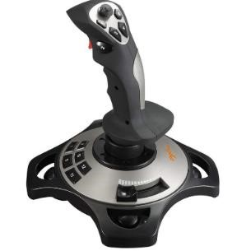
 |  | 4 | Light pen | 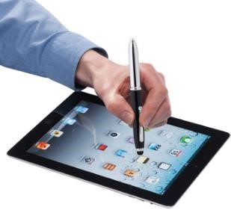
 |  | 5 | Trackball | 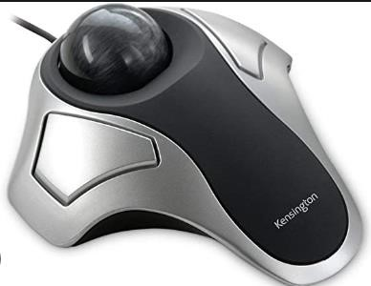
2. | Keying devices Help to enter data by pressing the keys | 1 | Keyboard | 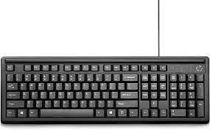
 |  | 2 | Keypads | 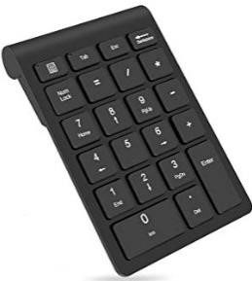

 |  | 3 | Touch screen key pads | 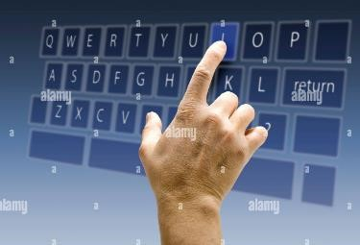
 |  | 4 | Television remote | 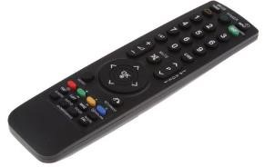
3 | Scanning devices Used to capture data directly from the source and convert it into a form  the computer can understand. | 1 | Barcode reader | 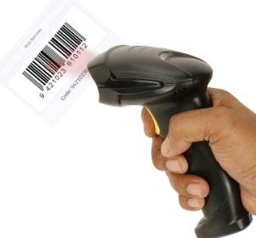
 |  | 2 | Optical character reader | 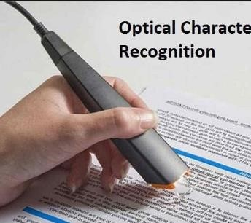
 |  | 3 | Magnetic ink character reader | 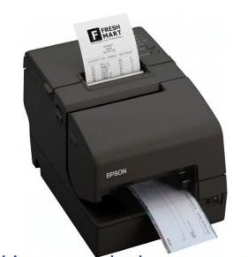
 |  | 4 | Optical mark reader | 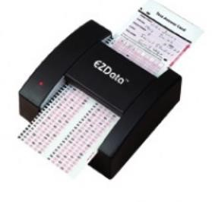
 |  | 5 | Magnetic stripe reader | 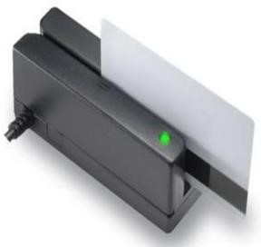
4 | Voice input devices They enter data and instructions into a computer in form of speech. | 1 | Microphone | 

Appropriate input devices for different situations.
Factors to consider when selecting input devices.
- User needs-the device should meet the need of the user.
- Type of data to be input.
- Available space for the input devices.
- Volume of the data to be input.
- Accuracy of the input devices.
- Cost of the input devices-the device shot be affordable.
- Compatibility-it is the ability of the input devices to work with the existing computer hardware. The device should be able to work together with other available devices in the computer.
Reusing Input devices to minimize wastage.

- Input devices that are in good condition can be reused to minimize waste.
- Computers keyboards can be used to make: book covers, pencil holders, key holders, rings and fridge notes.
- A computer mouse can be used to make toys, soap dishes, toothbrush holders and Christmas tree decorations.
- Obsolete and dysfunctional input devices can be sent to recycling facility where they will be recycled to make new products.

Output Devices.
- Processed data can be given out in form of audio, text, pictures, graphics or videos.  Output devices are used to give out information from the computer.

Output devices of a computer. `
- Output devices are peripheral devices that give out information from a computer to the user.
- Examples of output devices are: monitors, printers, actuators, plotters, speakers, earphones and projectors.

Functions of Output devices.
- Monitor
  - It displays data in text and graphics.
- Speakers.
  - Gives information in form of sound or audio.
- Headphones/earphones.
  - Produce audio information.
- Printers.
  - Produce text or picture on paper.
- Projectors.
  - Gives visual information by projecting it on a flat smooth like wall or a white board.

- Plotters.
  - Produces digital created graphics and drawings. A plotter uses a pen to draw lines on paper.

- Actuators.
  - A part of a device or machine that helps to create physical movement using signals from a computer.

- Braille embosser.

  - A device that presses dots onto paper for people with visual impairment to read using their fingers.

Categories of Computer Output devices
Softcopy output devices.
- They give intangible output in form of text, audios and videos.  These devices include; monitors, speakers and projectors.

Hardcopy output devices.
- They give tangible output that is in form of printed text or graphics.  Examples of hardcopy output devices are printers and plotters.

Advantages and disadvantages of Softcopy and Hardcopy output.
Advantages of hardcopy Disadvantages of hardcopy
It is considered permanent data as editing It is expensive to produce as it requires and changing is not easy. paper, ink and printer.
It does not need electricity, special devices It is not easy to move from one place to or software to display/show another.
When properly stored it is not easily lost It requires a lot of physical storage space.
It is not subjected to data stealing and cyber It can be stolen or destroyed through wear
attacks and tear or be subjected to factors such as
fire and water.
Advantages of softcopy Disadvantages of softcopy
It is easy to move from one place to It is vulnerable to cyber and data stealing. another.
It is cheap to produce as it does not require It requires electricity, a device and software to paper or ink. be displayed or shown.
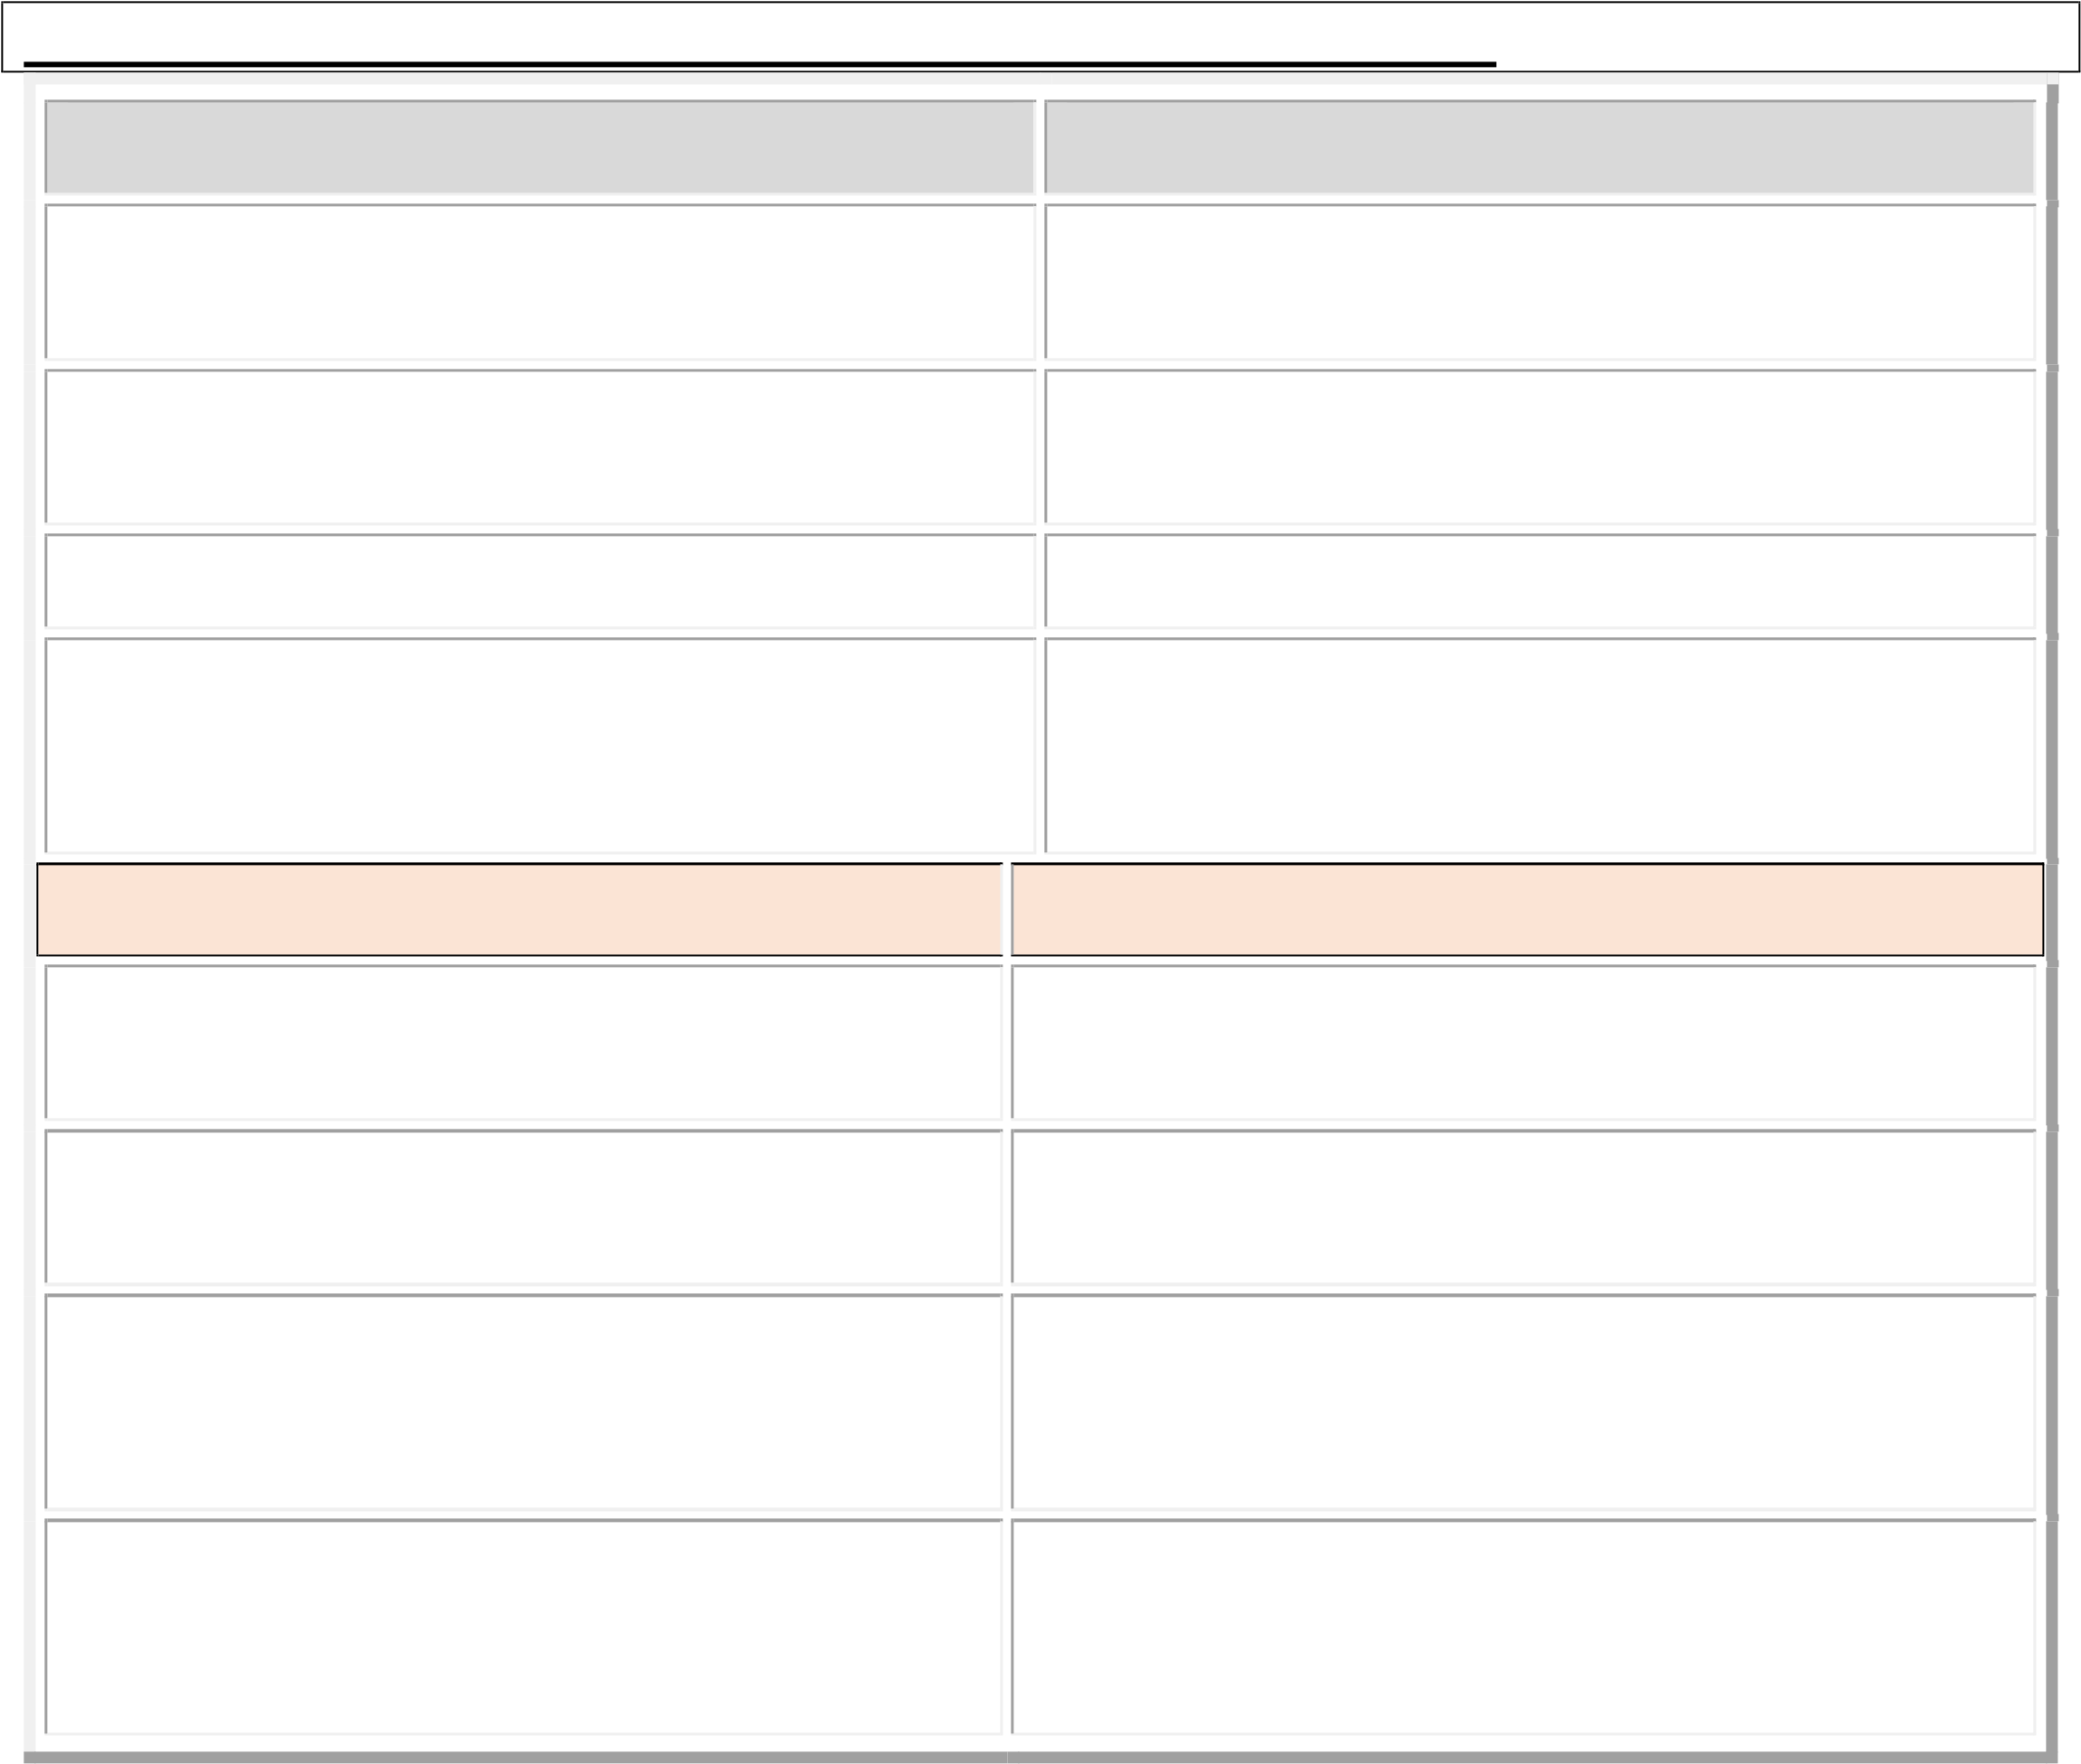
Large amount of data and information can It is considered temporary data which can be be stored without the need for a lot of altered or manipulated. physical space.
It is beneficial to the environment as it reduces the number of trees cut to make paper.

Appropriate Output devices for different situations. Factors to consider when selecting output devices.
- Number of people receiving the output  i.e. large audience will need projector  for display and speakers for audio.   - Portability-determines the type of  output device used.   - Environment in which the output  device will operate.   - Nature of expected output/ Output quality.  We care and use output devices by:  - Keeping the devices away from water and dust.  - Avoiding exposure to foods and fluids.  - Always powering off the devices after use.  - Connecting only with compatible devices.  - Cleaning and servicing the devices regularly.  - Ensuring secure connection of the devices before use. | User friendliness.  User needs.  Suitability to the function it is intended to carry out.  Compatibility with the available devices.  The cost of purchasing and maintaining the output devices.
Storage Devices.
- Storage devices are used to store data and information.
- They save data, information, computer softwares and running operations.
- Examples of storage devices include hard disk, memory card, flash disk and external hard disks.
Fixed storage devices.
- Fixed storage devices are secondary storage devices housed inside the computer.
- They help the primary storage devices by storing data permanently for a longer period of time.
Examples of fixed storage devices found inside a computer.
 Hard drive disk (HDD)  Solid state drive (SSD)  Internal Flash drive.

Hard disk drive | Solid state drive | Internal flash drive
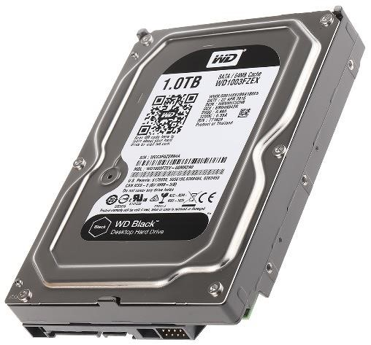 | 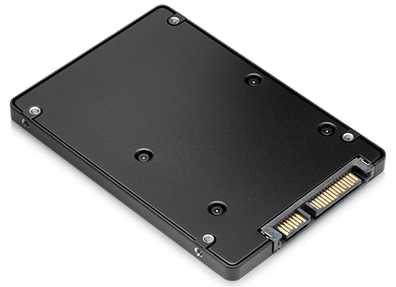 | 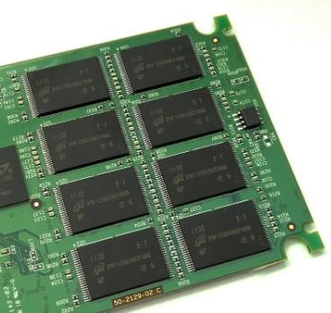

Features of Fixed storage devices.
- The devices are usually found inside the computer case.
- They are non-volatile and data stored will remain saved even when power supply is interrupted.
- Their storage capacity is high.
- They can be read from and written to.
- Thet are cheaper compared to primary storage devices.

Advantages of fixed storage devices.
 They store data permanently.
 They provide fast access to data.
 They have large storage capacities.

A hard disk drive.
- Usually has one or more metallic platters stacked on top of each other.
- The stack of platters is attached to a rotating pole called spindle.
- The platters are used to store data.
- Data is read and written to a hard disk using the principle of magnetism.

Solid state drive.
- Uses integrated circuits to store data permanently.
- Data in solid state drives is accessed randomly.
- Solid state drives are used in personal computers such as laptops, cameras, tablets and smartphones.

The internal flash memory.
- A nonvolatile memory used to store data in computers, digital cameras, universal serial bus, flash drives and mp3 players.
- Data in flash memory can be electrically erased and new data stored in it.

Location of Fixed storage devices in a computer.
- Some fixed storage devices in a computer such as the hard disk and solid-state drive are usually found in the drive bay of the computer case or on underside of a laptop.
- Some solid-state drives are embedded on the motherboard.
- Internal flash drives are mostly located in small portable devices such as mobile phones and cameras.
How data is stored (Written) and retrieved (read) from fixed storage devices.
- Writing data or saving data means storing data.
- Data is written on a fixed storage device by:
  - Creating new files.
  - Downloading.
  - Copying or moving files and saving them in a computer storage device.
- Reading Data, retrieving data or opening data is same as getting data back from its location.
- When data is opened or a file is accessed in a fixed storage device then the data is read.
Give the advantages and disadvantages of Fixed storage devices in a computer.
The following table clearly gives the advantages and disadvantages of Fixed storage devices.
Advantages | Disadvantages.
They are non-volatile storage devices hence data stored is available regardless of power supply. | They are vulnerable to mechanical failure since they contain moving parts.
They have a large storage capacity allowing storage of large amounts of data. | Data stored requires back up in another device because the disks are fragile and can fail.
They allow reading and writing of data. | The hard disk consumes more power during read and write activities.
They are cheaper in price compared to primary memory. | Some are expensive like the solid-state drive.
They are durable. They have a long lifespan and can handle many read and write cycles. | They have a slower read and write speed compared to primary storage devices.
They can be used to back up data for long periods of time. | Fixed storage devices are not portable and do not allow easy transfer of files to another computer.
They are available in the market in different capacities as per the user requirements.
They are not easily lost since they are fixed inside the computer.
How to manage waste from fixed storage devices:
- Always reuse the devices if still in good conditions or sell at a lower price.
- Return the device its manufacturer for reuse or recycling.
- Take the device to an e-waste management center for recycling and proper disposal.
Removable storage devices
- These are portable storage devices that are not housed or fixed inside the computer case.
- The have to be connected or attached to a computer system through a port so that data can be read from or written to them.
- They can be used for backup and store and transfer of data from one computer to another.
Types of Removable storage devices.
- External hard drives.  Universal Serial Bus (USB)  Flash drive.
- Memory drives.
- Memory cards.
- Compact discs (CDs).
- Digital versatile discs (DVDs).
- Blu-ray discs.
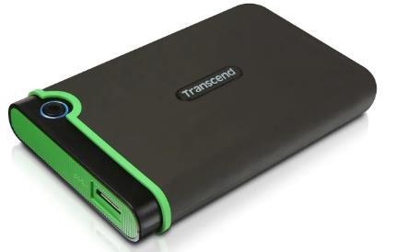  External hard drive. | 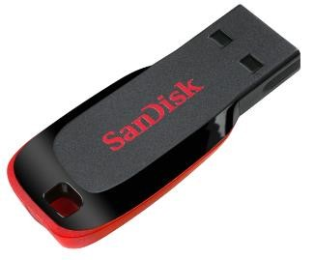  Universal serial bus.
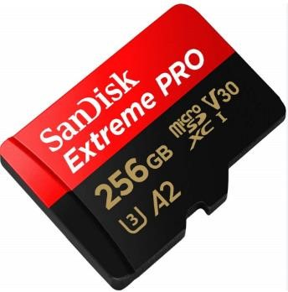  Memory card | 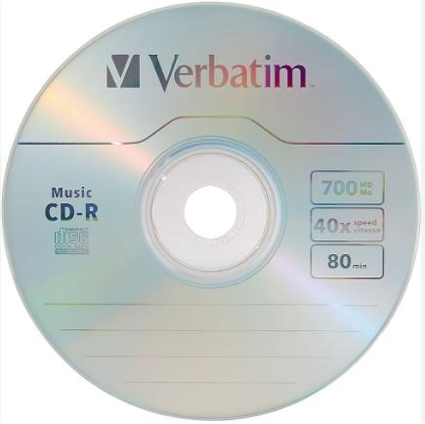  Compact disc.

Digital versatile disc  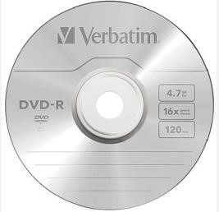 | Blu-ray disc  
Floppy disc.  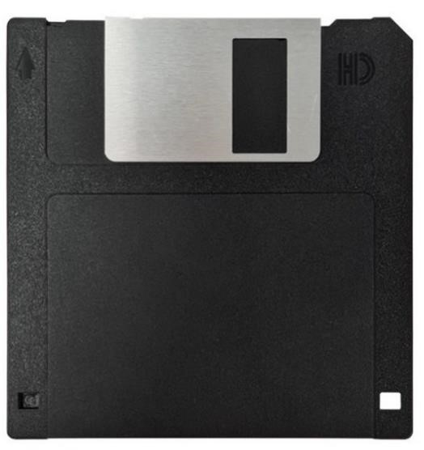 | Floppy disc  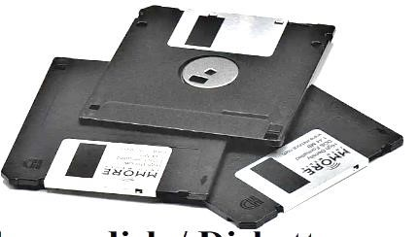
Removable storage devices are used in a computing environment because:
- They are portable and can be used for transporting data and information from one computer to another.
- They can be used to back up data away from the computer in case the original data is lost or damaged.
- They can be read from or written to easily without affecting the operations of the computer.
- They enable sharing of information and data among computer users.
- They can store and be used to install critical applications like operating system in a computer.

Factors to consider when selecting a removable storage device for use:
- Storage capacity.  - Data transfer rate.  - Compatibility/  - Cost of the storage device.  - Physical size. | - Portability.  - Durability.  - Current technology.  - User needs.

Advantages of removable storage devices over fixed storage devices.
- Easy transfer of data and sharing between computer and users.
- Portable-can store data while outside or not attached to a computer.
- Easily read from and written to.
1.3-Consumer and Investor Protection.
- Consumer protection refers to measures by either the government of NGO or consumers to avoid exploitation of consumers by business people.
- It is a deliberate attempt to safe guard consumers against exploitation or malpractices in business.
- Investor protection -

Importance of consumer protection.
 Prevents consumers from access poor quality goods and services.
 Prevents consumers from purchase of goods and services under unhygienic conditions and environment.
 Protects consumers from over priced goods and services.
 Protects consumer against underweight goods and inadequate services.
 Protects consumers against illegal goods and services.
 Protects consumers against harmful goods and services.
 Protects consumers against hoarding of goods to create an artificial shortage.

Ways in which consumers and investors protect themselves.
  - Educate members on their rights as consumers.
  - Ensure regular supply of goods to avoid hoarding to create shortages.
  - Ensure health and safety regulations are followed.
  - Forming consumer associations to deal with all consumer related issues.

Ways in which the government protects consumers and investors.
- Form laws that protect consumers such as public health act to ensure health and safety standards are met.
- Encourage formation of consumer organisations to deal with consumers interests.
- Encourage businesses to conduct their affairs in a way that does not exploit consumers interests.

Ways in which Non-Governmental Organisations protect consumers and investors.
 Ensure standards are maintained by bot h producers and traders.  Customer protection by informing customers on their rights.

STRAND 2-COMMUNICATION.
2.1-Business Communication.
- Communication is the process of sharing information through a channel from the sender to the receiver.
- Business communication is the exchange of information between a business organization and its customers or between people within and outside a company.
- When business communication is done correctly, everyone can do their job, all of which increases productivity and even creativity.
- A communication channel is a medium or method that is used to deliver a message to an intended audience.

Forms of communication channels used in Business.
- Oral/verbal communication channels.
- Written communication channels.
- Audio-visual communication channels.

Oral/verbal communication channels.
- It involves speaking and listening by both the sender and the receiver.
- Examples of oral communication channels include:
 Face to face conversations.
 Group presentations.
 Telephone calls.
 Speeches.
 Lectures.
Advantages and disadvantages of oral communication channels.
 | Advantages | Disadvantages.
1 | Sharing of information is quicker especially through phone call or one on one conversation. | Not possible to tell if everybody is listening to you especially when dealing with a large group.
2 | Feedback is shared immediately. | Sometimes there is no record kept for future reference.
3 | Oral communication channels are suitable where persuasion is required. | Misinterpretation of the message may occur due to tone variation and mispronunciation of word.
4 | They are cheap. | Misunderstanding may occur when the message is misinterpreted.
5 | The sender can reinforce the message by using body language. | They could results in boredom and disengagement when a lot of information is being shared.

Written communication channels.
- They involve use of text to pass information.
- The text can be handwritten, printed or shared using digital communication devices.  Examples of written channels of communication in businesses are:
 Emails.  Letters.
 Memos.
 Reports.
 Circulars.
 Short message services (SMS)  Newsletters.
 | Written communication channel | Description.
1 | Letter | A written or printed message that is addressed to a person or organisation. It can be formal or informal and is usually delivered by hand or mail.
2 | Memo | A short official note that is sent by one person to another or to a group of people within the same business organisation.
3 | Circular | An official letter addressed to many people outside the business organisation.
4 | Notice | Communication used to tell or warn about something that is going to happen.
5 | Minutes | Written record of what happened in an official meeting.
6 | Report. | An account or statement giving details of an event or a situation, usually as a result of observation or inquiry.
7 | Email. | A formal method of exchanging messages or communication from one person to another or more recipients through the internet.

Advantages and disadvantages of written communication channels.
 | Advantages | Disadvantages.
1 | Suitable for sending detailed information such as business reports. | There is no immediate feedback from the receiver of information.
2 | Easy to keep records of information in physical files or digital devices e.g., emails and typed documents. | Some such as letters and reports are costly in some circumstances.
3 | It ensures clarity of information as a person can read the information several times. E.g. a letter and minutes. | The receiver of a letter or circular may not get a chance to seek clarification on the information.
4 | They are ideal for passing confidential information o stakeholders in business e.g., memos and letters | They are not suitable for people who cannot read and write.
5 | They ensure there is no distortion of information because it is received as the sender intended. | Body language in all written communication channel cannot be used to enhance understanding of the message.

Audio-visual communication channels.
- It involves a combination of different content forms such as text, audio, images, video and animation.
- Examples are:
 social media platforms.
 Blogs.
 Televisions.
 Video-conferencing.
 Websites.

Advantages and disadvantages of audio-visual communication channels.
 | Advantages | Disadvantages.
1 | Business information can be sent and received instantly, anywhere in the world through internet or television. | Information overload-exposes users to a lot of content flow in addition to the intended information.
2 | They allow for information to be changed and to be updated, for example blogs and social media. | It can lead to time wastage for example one can spend a lot of time scrolling through other content on smartphone or computer even after receiving the intended message.
3 | They are flexible-one can send or receive information from anywhere in the world. | Not all people have the gadgets that support multimedia communication channels.
4 | Makes it easier for the sender and receiver of information to interact and share feedback in real time. For example, emails and social media. | They can be costly because they involve getting specialized equipment and skilled people to compile and package information before it is sent to the target audience.
5 | Due to their easy integrated nature, they allow for easy understanding of the information shared. | They may be subject to cyber security threats such as hacking, which threaten the policy of the information.
6 | They can be used to reach many people and to engage them all at once, for example television and radio.
7 | They are exciting to use due to their interactive nature, for example social media.

Factors considered when selecting channels of communication.
- Cost of the channel.
- Urgency of the message.
- Number of people receiving the message.
- Confidentiality of the message.
- Reliability of communication.
- Nature of the message: whether it is urgent, private or confidential.
- Need for immediate feedback.
- Supporting technology: both the sender and the receiver should have supporting tools to ensure the message is delivered successfully, for example mobile phones and internet connectivity.

2.2-Plain Scale Drawing.
- Plain scale drawing involves drawing a line that has been divided into a specific number of equal parts.
- The first part of the line is subdivided into equal smaller portions or units.
- It can be used to represent two units, a unit or a fraction of a unit.
- Plain scale is used in engineering drawings to measure up to two units such as metre and decimeters or feet and inches.
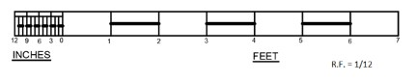
Interpreting a plain scale used in drawing.
- A representative fraction (R.F) is the ration od the size of a feature on a drawing to its true size on the object.
- It is expressed in fraction form as R/F
- A plain scale can be constructed using the example below.
Example 1.:
On a drawing, 1 cm represents 1,5m on the ground.
Draw a plain scale to measure up to 30m in 5m interval. Show the length of 27m on the scale.

Steps to follow.
Step 1

    - Determine the scale to use.
    - In our case 1cm represents 1.5m or 150cm.
    - In this example, it is appropriate to use Centimetres.

Step 2.
    - Calculate the Representative fraction, R.F
    - R.F = measurement on the map divided by measurement on the ground.  R.F =1cm/1.5m  R.F =1/150.
    - R.F =1:150.

Step 3.
    - Calculate the maximum length of the scale to read 30 metres length.
    - Measurement on map =R. F x measurement on the ground.  Measurement on map =1/150 x3000  Measurement on map =20.

Step 4
    - Draw a straight line 20cm long and divide it into 6 equal parts.
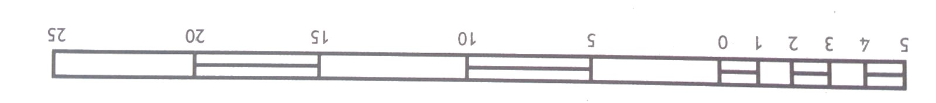
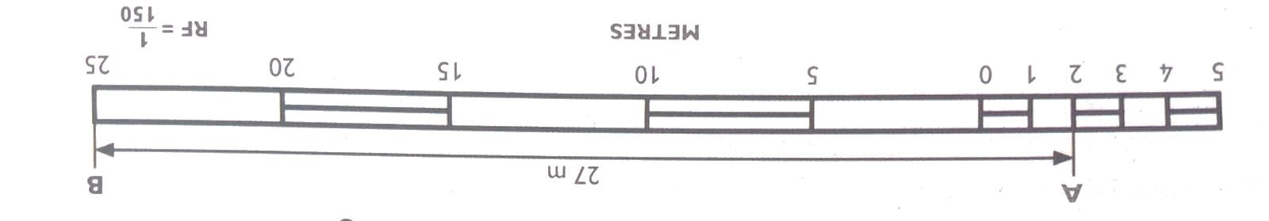
    - Divide again first part into 5 equal parts.
    - Indicate the number on the points on the line as shown.
▪
    - To show length 27m, draw a line AB above the scale with and B at 25 m mark on the main scale. Extend the line for point A to be at point 2m on the smaller scale. Complete the drawing with all details.

Example 2:
On a scale 1:150, determine the length of line PQ as shown in the figure.
Give your answer in metres.
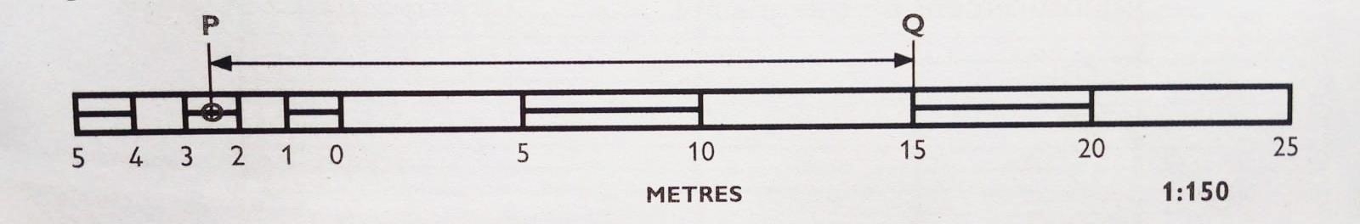
Steps to follow.
- Determine where line begins on the main scale. In this example, point Q is at the 15m mark.
- Determine the point on the smaller scale where the line reaches. From the diagram above, point P is between 2 and 3 on the smaller scale. Therefore, this point represents 2.5m from 0.
- Combine the two values such that 15 is the value on main scale, while 2.5 is the value from smaller scale.
- Therefore, length of the line PQ is 15 + 2.5= 17.5 m.

Example 3
- On a drawing of scale 1.5, the length of a line is a s shown in the diagram. The unit of the scale is decimeters. Determine the length of the line in centimetres.
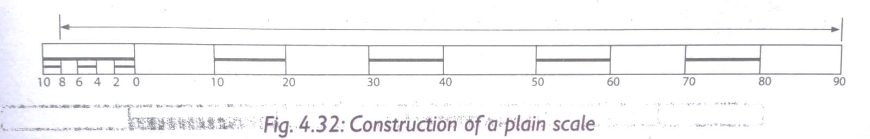
    - Determine where the line begins on the main scale. In this came point is at 9cm mark.
    - Determine the point on the smaller scale where the line reaches. From this case it is 8 mark representing a length of 8cm.
    - Combine the two values such that: 90cm (9dm) is the value rom main scale and 8cm is the value from smaller scale, 90 cm + 8cm =98cm.
    - Hence the length of the line = 98cm.

2.3 Visual Programming.
 Introduction.
- Visual programming is developing applications using graphical components and figures.  These graphical components and figures mostly include images and video clips.

 Types of visual programming applications.
- Visual programming is also called block-based programming.
- It is a way of creating applications using graphical components and figures. This is mostly done through the use of code blocks and drag-and drop processes.
- The most common examples of visual programming applications are:
    - Microsoft MakeCode.
    - Scratch.
    - Code.org.
    - Sprite box.
    - Microsoft Visual Studio.
    - Roblox.
    - Minecraft.
- Visual programming applications are used because they are easy and interesting to use. They also help in creating stories, animations and videos that entertain users.

 Launching a visual programming application.
    - Type the word Scratch in the search box. The Scratch application will appear.  Click on the Scratch application to launch it.
    - Alternatively, click Start.
    - Scroll down to category S then click on Scratch App. The application will launch.

Visual Programming Features.
 Features of Scratch.
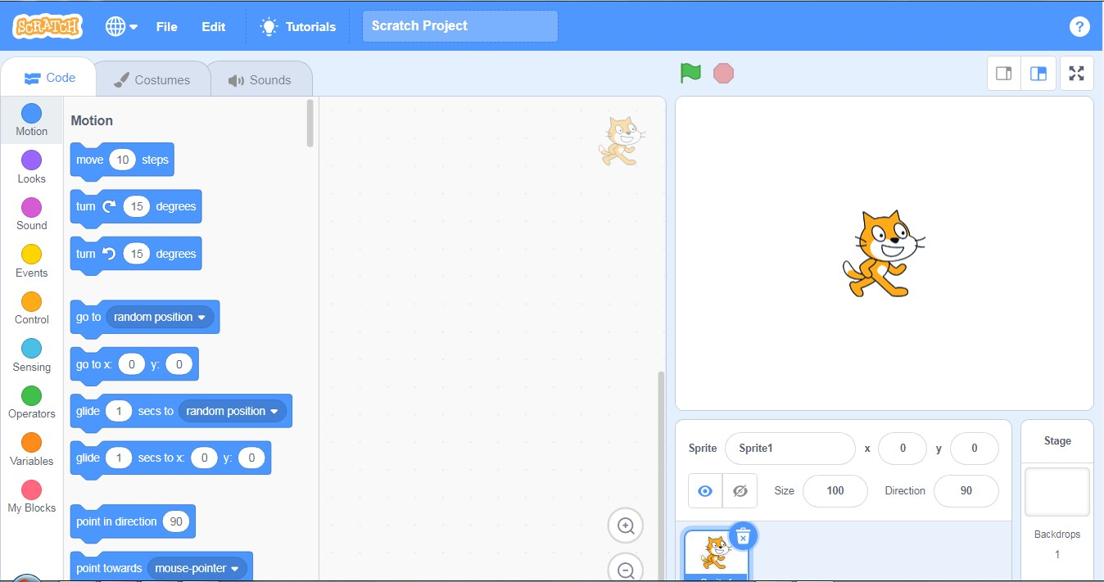
 Scratch is a visual programming language that can be used to create interactive stories, games and animations. Features of scratch include:
    - The menu bar-it contains the fie menu used to save and load projects and the view menu which displays rulers, grid lines, status, zoom in and out options.
    - The black palette-it contains a coloured set of code blocks that are used to program and give instructions to the sprite.
    - The stage-it is the main working area where the sprite moves and performs according to the given code of instruction.
    - Backdrops pane-it is the part used to add a back ground to the project.  Functions of the features of Scratch.
Feature | Function
Sprite | It is also called the coding area. it is where codes (scripts) area created for a sprite to do a specific action.
Sprite area | Are blocks shaped differently and are used to create codes in Scratch.
Code blocks | A small graphic character that performs actions such as moving around the stage.
Sprite pane | Shows information about the size of each sprite.
Sprite info | Displays all the sprites in a project
    - A sprite is a small graphic character that performs actions such as moving around the stage.
    - The script area is also called the coding area; it is where codes (scripts) are created for a sprite to do a specific action. Codes are dragged and dropped here then snapped together to create a program.
    - Code blocks are blocks shaped differently and are used to create codes in Scratch. The codes connect to each other vertically like a jigsaw.
    - The sprite info shows information about the size of each sprite.
    - The sprite pane displays all the sprites in a project. A selected sprite has a blue border around it.

NB
    - To move the sprite, add a move block from the motion category.
    - To add sound, click on sound category and choose a sound block.
    - To move the sprite back, use a negative value on the move back block. The block can be repeatedly severally to generate the desired animation.

 Terminologies used in visual programming applications.
    - The start option commands the sprite to perform moves, it is represented by a green flag
. When you click stop the sprite ends its moves.
    - Reserved words are also known as key words. These are words with a special meaning to the programming application. In scratch they are words that we cannot edit on the blocks. They include when, by and change.
    - The rules that should be followed when writing a program using an application are called syntax.
    - Input statement are blocks that are used to create animations.
    - Output statements are outcomes of the processed instructions that are programmed using clocks. These are the actions viewed on the stage when the blocks are executing.
    - Control structures are the blocks that allow selecting or repeating execution of certain blocks or instructions.

    - A backdrop is the background for the stage. Backdrops can be changed from the gallery or photo in the computer.

    - The sensing category helps one to enable input from the mouse, keyboard and other input devices. ’IF’ is used to choose between two output. For example, it can be used to perform mathematical calculations and state whether the answer given is correct or not

STRAND 3-MATERIALS FOR PRODUCTION.
3.1 – Composite Materials.
Identification of Composite materials.
- A composite material is formed by combining two or more materials of different characteristics.
- Some of the composite materials found in the locality include:
 Mud.   Stone.   Sand paper.   Chip board and ply wood.   Concrete.   Mortar. |  Bituminous felt.   Fiberglass.   Papier mache.   Putty.   Rubber.
Composition of composite materials.
Different composite materials are made of different materials as described in the table below.
 | Material | Composition
1 | Fibre glass | Fine glass particles or plastic fibre and resins.
2 | Mud | Soil and water.
3 | Papier mache | Paper pieces or pulp and adhesive (glue, starch or wallpaper paste)
4 | Stone | Different natural materials.
5 | Manufactured boards | Wood waste like saw dust or wood shavings and glue.
6 | Concrete | Cement, sand, water and coarse aggregates.
7 | Mortar | Cement, sand and water.
8 | Rubber | Natural latex, fibres and other additives.
9 | Bituminous felt | Petroleum by -products and sand particles.
10 | Window putty | Limestone and oil.
11 | Sand paper | Piece of cloth or paper, glue and sand particles.

Uses of Composite materials.
Some of the uses of composite materials are explained as follows:
- In sports industry, composite materials are used to make various games and sports items. o Composite materials are used to make body parts of vehicles and bicycles.
- Composites materials are used to make customer goods and electronics such as mobile phones, television sets, radios and calculators.
- At home, composite materials are used to make hand tools and furniture.
- In construction industry, composites like concrete are used to build houses and to construct roads and bridges among other structures.
- In medical engineering, composite materials are used to make artificial body parts and implants.
- In transport industry, composite materials are used to make the body parts of vehicles, aeroplane, ships and boats among others. It is also used to make travelling bags and briefcases.

NOTE:
  - Artificial body parts are also called prosthetics.
  - Prosthetics limbs are given to substitute missing body parts.
  - These body parts may have been lost in an accident or through amputation.
  - The prosthetic body parts help people with missing limbs to function properly and with ease despite the missing body parts

Careers in use of Composite materials.
- Masonry-involves use of mortar, stones and concrete to construct structures.
- Pottery- involves use of mud to make pots, dishes, mugs, vases and other types of artworks.
- Interior design – involves use of papier mache and manufactured boards to decorate interior of houses and motor vehicles.
- Sculpting -involves uses of clay, fiberglass, stone or concrete to make sculptures.
- Boat construction -involves use of fiberglass to construct boats that are light and resistant to corrosion.
- Carpentry – involves use of manufactured boards to make furniture, construct ceilings and other finishes in a building.

Importance of composite materials used in the locality.
- Promote recreation that improves health.
- Providing employment.
- Use of manufactures boards such as blockboards, softboards or chipboards to reduce deforestation through recycling of waste.
- Improves the appearance in landscaping of compounds

3.2 -Ceramic materials.
- A ceramic material is made by mixing clay, earthen elements like silica, kaolin, alumina and feldspar, and water.
- The material is thoroughly kneaded, shaped into desired forms and baked before being covered in decorative, waterproof, paint-like substances called glazes.
- Some ceramic materials like sea shells occur naturally.
- The common type of ceramic materials are:
    - Earthenware- clay heated at temperatures of between 1000⁰C and 1150⁰C. An example is clay used to make pot.
    - Stoneware – clay heated at an average temperature of 1200⁰C until it appears like glass. An example is material used to make a stoneware mug.
    - Porcelain -clay mixed with glass and heated at high temperature of between 1200⁰C and 1450⁰C. Example is material used to make a porcelain cup.

Most common ceramics materials found in the locality.
 Ceramic tiles.
 Glass.
 Backed clay bricks.
 Clay tiles.

Physical properties of Ceramic materials.
  - Ceramic materials break easily when crushed.
  - Ceramic materials are poor conductors of electricity.
  - Ceramic materials have a hard surface which is difficult to scratch.
  - Ceramic materials are resistant to corrosion.
  - Ceramic materials do not absorb water.
  - Ceramic materials do not bend.
  - Ceramic materials do not burn.

Uses of ceramic materials.
- In electrical and electronic engineering, ceramics are used to make items like resistors, semiconductors and inductors etc.
- Ceramic materials are used to make a variety of pottery items like pots and utensils.
- In the manufacturing industry, ceramics are used to make a variety of household utensils.
- Ceramics are used in plumbing works to make drainage installations and sanitary fittings such as toilets and wash basins,
- In construction, ceramics like bricks and tiles are used in building construction for walling, roofing and finishing materials.
- In beautification, ceramics are used to produce items like flower vase, lamp stand and souvenirs.

STRAND 4 -TOOLS AND PRODUCTION.
4.1 Cutting tools.
Identify and uses of various cutting tools.
- A cutting tool is a device that is used to chop, split, shape or remove excess materials from a workpiece.
- The common cutting tools are as follows:
  - Knife-a small tool that has a sharp metal blade fastened to a handle.
  - Its purpose is to cut cords, cutting and scrapping hides, reshaping timber, carving, cutting paper and kitchen work.
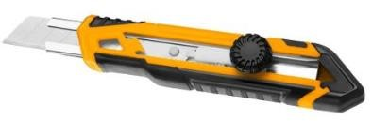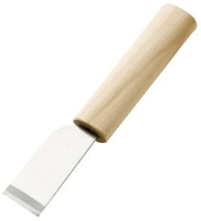
Utility knife Skiving knife
  - Panga-it is also called a machete.
  - It is a tool made of a broad metallic blade with shapes.
  - Used to chop wood as well as cut tree branches, shrubs and long weeds. Mainly used in fields of woodwork, construction and gardening.
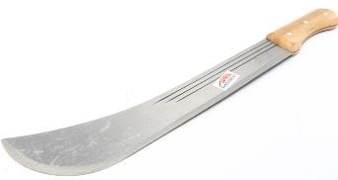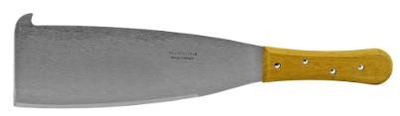

  - Axe-an axe is a woodwork tool.
  - It is used to cut, split and shape wood.
  - It is used to in the woodwork conversion industry as well as in the stone carving industry.
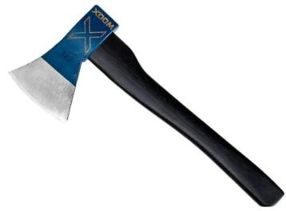

Scissors-it is a tool that has to blades joined together at the middle so that the sharp edges can slide each other.
  - They are of different types such as tailors’ scissors, barber’s scissors, paper scissors and surgical scissors.
  - They are used for cutting cloth, foil and paper, among others
  - Scissors are used in fields like textile, medicine, beauty and leisure industry.
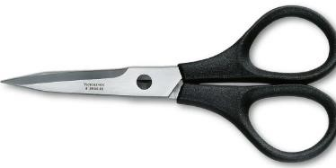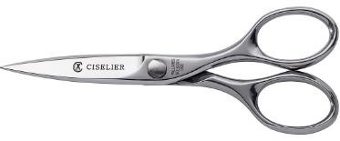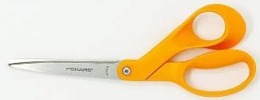

  - Shears-a tool that has two blades joined together at the middle so that the sharp blades slide against each other,
  - They are of different types.
  - They are used to cut tough materials like leather, canvas and rubber.
  - Shears are used by workers in leather industry, furniture industry and interior design.
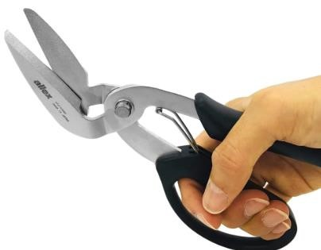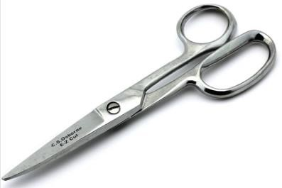

Carton shears. Leather shears.

  - Snips-they are hand tools used to cut sheet metals and other tough materials.
  - They come in different sizes.
  - Mainly used in area such as construction, sheet metal work and leather industry.
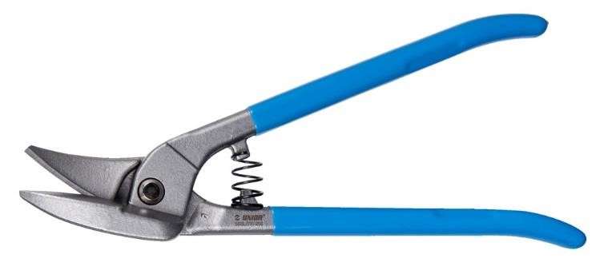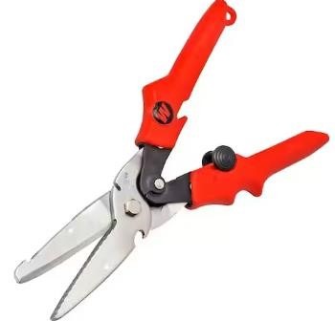

Secateurs-also called pruning shears-
  - It is a cutting tool that looks like a pair of strong, heavy scissors.
  - Used to prune flowers and small branches of shrubs,  Main used in gardening and landscaping among others.
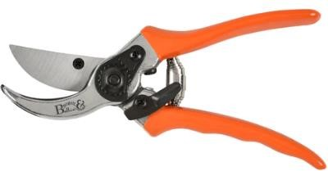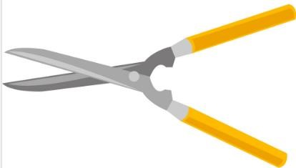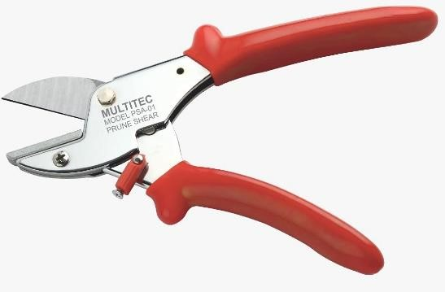

  - Hand saw-a hand tool with toothed edge.
  - Comes in different types.
  - Main used in the field of woodwork, carpentry, gardening and building construction.
  - Used to:
    - Cut wood and wood products.
    - Cat joints in carpentry and woodwork.  Prune trees and large shrubs.
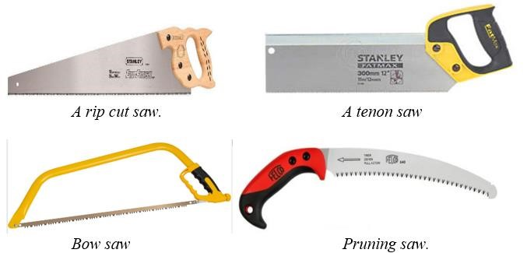
  - Hack saw-it is a cutting tool made of thin blade held across a –frame.
  - Used to cut through thin materials such as plastic or metal pipes in the fields of plumbing, steel fixing, electrical installations and metal work
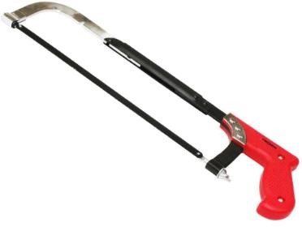
Plane- a general purpose woodwork tool for smothering the surface of timber by removing excess material.
  - It is used for shaving wood to provide uniformity to the wooden surface.  Mainly used in carpentry and woodwork.
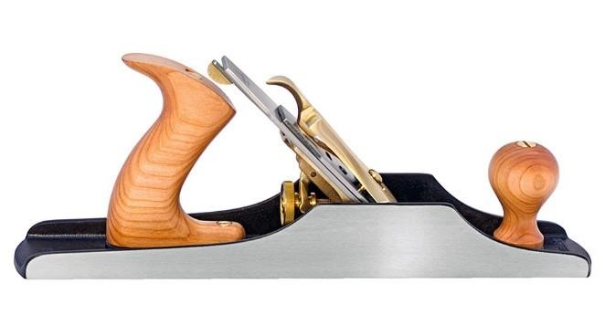

  - Chisel-a hand tool with a characteristic shaped cutting edge of blade on its ends.
  - Comes in different types.
  - Used for carving, cutting and shaping hard materials such as wood, stone or metal.  Used in fields like woodwork, metal work, masonry and stone carving.
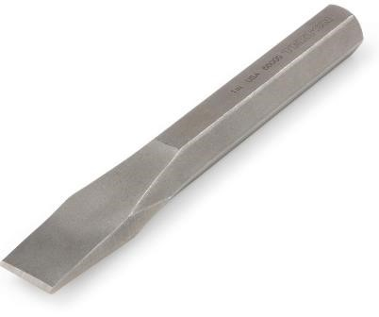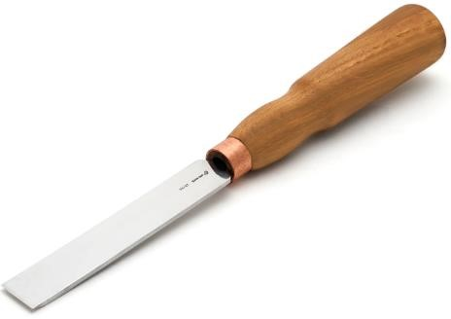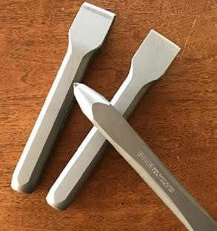

Cold chisel Wood chisel Stone chisel

  - Strap cutter-it is a handheld tool with a sharp blade.
  - Used to cut long lengths of leather materials into consistent widths.
  - It is used in the leather industry to cut strap blanks such as belts, guitar straps etc.
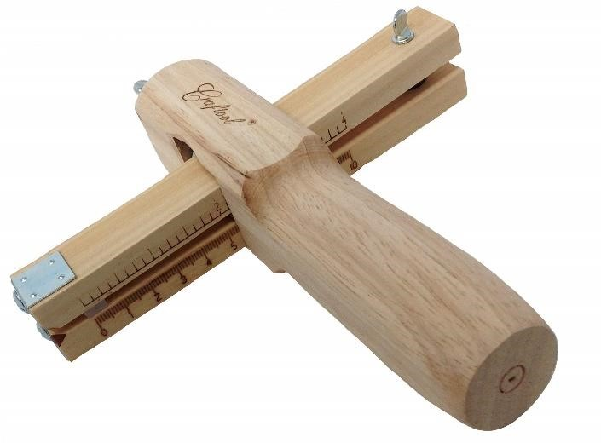

Bolt cutter-it is a tool with two handles and two short blades.
  - It is used to cut bolts, chains, padlocks and wire mesh.
  - Mainly used in mechanical engineering and metal work.
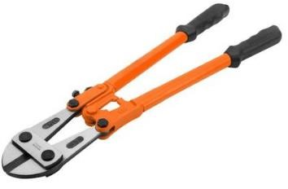

  - Pipe cutter-also called tube cutter, a pipe cutter us a type of tool used by plumbers to cut pipes.
  - Pipe cutters come in different shapes and designs.
  - It is used to cut pipes and tubes.
  - Pipe cutters come in different shapes and sizes.
  - Mainly used by plumbers and other tradespeople.
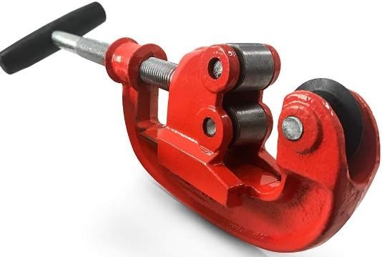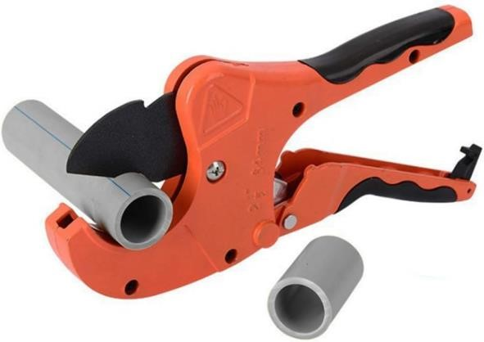

  - Scrapper- it is a hand tool that has a small handle and a metallic or plastic blade,  Used to remove a wide range of materials from various surfaces such as walls and floors.
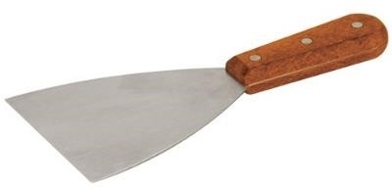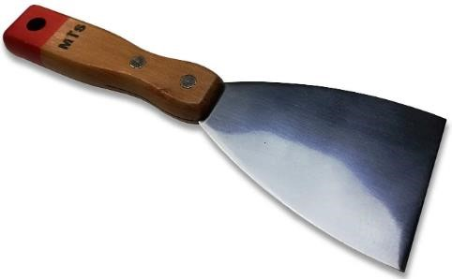

Care for cutting tools.
- Caring for cutting tools is the process of keeping them in good condition even when they are not being used.
- Some of the ways of caring for cutting tools in the work environment are:
 Inspect tools regularly as some manufacturers have specific instructions for how to use cutting tools that are the right size and type for the job.
 Follow the correct procedure for using every cutting tool.
 Keep your cutting tools, sharp and in good condition.
 Always carry pointed tools with the points and heavy ends facing down.
 Never carry cutting tools in your pocket.
 Keep your punches and chisels in good conditions because mushroomed heads can slip and cause injuries.
 Don’t use a cutting tool without a handle.
 Clean the cutting tool after use and return it to its proper storage place.
 Never place cutting tools where they hang on the edge of a bench.
 Store cutting tools vertically, with the points and heavy end facing down.
 Frequently clean and oil your scissors, snips and shears.
 Fit protective guards to sharp edges to prevent injury to you and damage to the tool.

Importance of Cutting Tools.
The importance of cutting tools in a work environment includes:
 Cutting tools enable workers to cut, shape and remove materials like metals, wood and plastics among others for use to make desired items in different work environment.
 It enables preservation of extra material from workplace. This enables the worker to only use materials that is required to make an item and leave the rest for others uses, thus lowering of cost of production.
 Cutting tools like saws, drills and blades are designed to make accurate cuts. They enable a worker achieve specific dimensions, angles and shapes required for a particular task or project.
 Cutting tools improve the appearance of items made by removing excess materials making the surface smoother.
 Working tools are used to accurately cut workpieces and their joints to the required size and shape. This enables the cut pieces and joints to fit properly.
 Some cutting tools have specialized uses. For example, mechanical workplaces, specialize cutting tools are used for shaping and modifying components and body parts for vehicle and building among others.

4.2 - Production Unit
A production unit is a business enterprise that uses economic resources to provide goods and services for sale, with aim of making a profit.
Examples of production units in your locality.
- Posho milli.
- Salon.
- Barber shop.
- Welding.
- Cybercafe etc.

Factors that determine the size of a production unit:
- Volume of output – large unit produce goods on large scale while small unit produce goods in small scale.
- Area covered by the premises –a unit covering large floor area is considered large while a unit covering a small floor area is considered small.
- Number of workers -a large unit has many workers while a small unit has few workers.
- Methods of production- highly mechanized unit with capital-intensive method of production are considered large. Small unit uses labour-intensive methods.
- Size of the market controlled- when a business controls a large portion of the total market, it is considered big. When a business controls a small portion of the total market, it is considered small.
- Capital invested- if a lot of capital is invested in a unit, it is considered big. Incase small amount of capital is invested in a unit; it means that the unit is small.
- Volume of sales- large units make large amount of sales, while small units make small amounts of sales.

Factors to consider when locating a production unit.
- Access to raw materials- raw materials should be readily available at affordable.
- Availability of labour-skilled and unskilled labour should be easy to access.
- Market-production units are usually located close to the market to cut on distribution costs.
- Government policies-to encourage production, the government may implement policies such as reduced taxes on imported raw materials, providing free land and building supporting infrastructure for business. Such like policies could be aimed at influencing location of production units in certain areas.
- Access to electricity and water supply-these are important in the operations of productions units.
- Access to supporting services such as banking, insurance and warehousing.  Access to social amenities to be used by employees and their family.

STRAND 5- ENTERPRENEURSHIP.
5.1 – Bookkeeping.

- Book keeping -This is the practice of recording and tracking on a regular basis the financial transactions of a business.
- It is done to keep records of a business which can be used anytime in decision making.

Importance of Book keeping in entrepreneurship.
- Making accurate budgeting possible.
- Book keeping provides important information that helps in ✓ Helps an entrepreneur prepare for taxes.
- Book keeping maintain organized records in a business.
- It also enables proper reporting to investors, aiding in setting and monitoring business goals, ensuring compliance with government regulations.
- Book keeping reveals the financial status of a business.

Classifying business transactions in entrepreneurship.
Business transactions in entrepreneurship can be classified as:
- Cash transactions.
- Credit transactions.

Cash transaction- is a transaction where payment is settled immediately.
Credit transaction is a transaction in which payment is settled or done at a later date as agreed by the parties.

Advantages of cash transaction.
  - It is simple and faster.
  - Use of cash transactions makes it easier to budget and stick to it.
  - It helps to avoid any additional charges. ✗ Personal information is protected.

Disadvantages of cash transactions.
  - Carrying large amount of money can be risky making parties involved vulnerable to theft and robbery.
  - May involve cases of fake money being used.

Advantages of Credit transactions.
- It provides a record of transactions.

Disadvantages of credit transactions.
- Customers may go bankrupt and fail to pay as agreed earlier.  Credit transaction may come with charges and interests.

Calculating assets, liabilities and Capital using the Bookkeeping formula.
What is an asset?
Assets are resources belonging to a business.
They are things owned by the business. Examples of assets include:
    - Money in hand (cash)
    - Money in bank accounts.
    - Properties such as buildings, machinery, furniture, crops and livestock, motor vehicles, tock or goods for sale.
    - Money other businesses owes you.

What is a liability?
Liabilities are debts you owe other business and other people.
Main examples of liabilities are:
- Creditors (money owed by the business to supplier)  Bank loans.
- Bank overdrafts.

What is Capital?
Capital is the amount of investment the business owner put or used to start a certain business.

Book keeping formula
Assets =liabilities + capital.

To calculate the Assets:
Calculate all the liabilities and adding them to the capital.
That means for one to find the capital used to start a certain business they have to calculate all the liabilities and subtract from all the total assets owned by the business.

5.2 – Income & Budgeting.
- Income-this is the money earned on a regular basis as payment of work done or as earning from an investment or business.
- A person can earn income when employed or self-employed.

Categories of income sources.
- Active sources of income.
This are income sources that require one to work to earn from them. Examples of active sources of income are:
  - Fees.
  - Wages.
  - Salaries.

- Passive sources of income.
These are sources of income resulting from work done to create an asset, painting or a block. These sources generate income for the owner without the person actively participating in the income generating process.
Examples of passive sources of income are:
  - Rent.
  - Dividends.
  - Interest.
  - Royalties (income earned from abilities and talents such as musician.)

Importance of budgeting in day-to day life.
A budget is an estimate of how one plans to spend income over a certain period of time. Budgeting is the process of making a plan on how to spend income.

Importance of budgeting.
 Helps one to have a clear picture of the amount of income that one had and how to spend it.
 Helps to control spending, therefore enables people to live within their means.
 Helps one to make and implement a saving plan.
 Helps to identify and avoid unnecessary expenses.

Ways of Spending money wisely in day-to-day life.
- Spending is the act of using money to pay for goods and services.
- Spending money wisely is about strictly buying items on budget and purchasing them at reasonable prices.
- One should make a priority list with items to spend money on.
- Some ways in which money is spend include:
  - Paying for basic needs such as food, clothes, water and healthcare.
  - Paying rent.
  - Paying school fees.
- Impulsive buying this is the tendency to buy items that a person had not planned for.
Ways of spending money wisely in day-to-day life.
- Make a budget and stick to it.
- Find out the prices of items in various shops and market for comparison purpose.
- Avoid impulsive buying by only purchasing items that are budgeted for.
- Buy in cash and make sure you carry enough cash for what you want to buy. ✓ Buying items on discount.

Preparing a simple budget for personal finance management.
A format of budget sample.
Step 1: list all your income of the month.
Step 2: list all things you want to spend money on and their prices. Start with the most urgent needs to the least urgent wants.
Step 3: Calculate the total cost of all the items you want to buy. Compare the total cost with the total amount to be spent, in your budget.
If the total cost exceeds your budget, adjust your list by removing the least important items. Step 4: Buy the items you have budgeted for.

Example.
 | Mr. Gitau’s Family budget for January, 2023.
Income | Amount (Ksh.)
Sale of dairy products 15,300.
Sale of poultry products 15,000.
Sale of vegetables 5,500.

Expenses Amount (Ksh.)
Savings 4,000.
Food 5,000.
Rent 8,000. School fees 7,500. Medical insurance 500.
Transport 2,000.
Airtime 1,500. Television subscription 800. Internet 2,000.
Donations to charity 1,000. Entertainment 1,500.
Task.
Calculate Mr. Gitau’s total: a. Income:
Income =15,300+15,000+3500=sh.33,800.
b. Expenses.
Expenses =400+5000+8000+7500+500+2000+1500+800+2000+1000+1500
=sh.30,200.
Ethical and unethical practices in budgeting and spending.
Ethical practices in budgeting and spending include:
  - Make budget and strictly following it.
  - Balance income and expenses and adjusting to situations accordingly.
  - Determining the amount one needs to save before spending money. ✓ Avoiding to carry excess cash when going for shopping.

Unethical practices in budgeting and spending include:
Unethical practices are bad behaviours or practices people adopt when spending money. These practices include:
  - Spending money without a budget.
  - Making a budget and not strictly following it.
  - Misusing money because of bad influence, for example, entertaining friends when family needs have not been met.
  - Postponing paying bills and clearing debts when one has money. ✓ Accumulating many unnecessary debts.

5.3 -Marketing of Goods & Services.
Meaning and importance of marketing.
- A market is where buyers and sellers interact to facilitate the exchange of goods and services.
- Marketing is the process of promoting and selling goods and services.
- Consumer is any person who buys goods and services for their personal use.
- Goods, produces and services offered should target a specific market or consumers of the goods or services. Marketing should target specific consumers.
Sources of information about the market and its potential customers.
Sources of information about the market and its potential customers include the following:
- Family and friends.
- Internet from websites and social media platforms or sites.
- Mass media such as radio, television and newspapers.
- Business dealings in similar products and services.
- Organisations that conduct research about markets.
- Customers of business dealings in similar products.
Factors to Consider when selecting a suitable market for goods and services.
  - The number of traders selling goods and services that are similar.
  - Accessibility of the market.
  - Consumers taste and preferences-levels of income and living standards.
  - The living standard of consumers.
  - Consumer potential-involves considering consumers spending habits, consumers purchasing potential.
  - Competition-one must consider the extent o competition as well as the strength of the competitor.
  - Market size-one needs to access whether the market is large enough for him to capture market share.
  - Demographic trends such as size, level of income.
  - Marital status.
  - Market cost and budget.
  - Physical infrastructure.
  - Market acceptance.
ICT Platforms used for marketing goods and services.
The following platforms are used for marketing goods and services.
  - Mobile phones that are used to communicate with consumers who are in different places.
  - Radios are used to advertise and promote goods to many consumers.
  - Television can be used to market goods and services to the consumers.
  - Social media such as Facebook, WhatsApp, Twitter among others have become the best platforms to market goods and services.
  - Internet provides platforms for marketing goods and services through online newspapers and magazines.
  - Emails can be used to market goods and services.
Methods of gathering information about the market and its potential customers:
- Observation-watch and note people behaviours to know their taste and preferences.
- Interviews-involves questions and answers.
- Surveys-gather information by asking targeted questions to a sample group of people.
- Focus on group discussions-gather information from a group of people who represents target market.

Gathering information about the market of a product;
Information about the market of a product can be gathered by:
 Visiting producer website.
 Checking for reviews on social media.  Conducting window shopping.
 Interviewing user of a similar product.
 Consulting family and friends

5.4 Saving and Investment
Saving-this is the act of setting aside a portion of your income not to spend it on the current expenditure but for the purpose of future use.
Investment- this is the acquiring of assets or items with the goal of generating income or appreciation.

Reasons for saving and investment in financial management.
    - Keep money safe for easy access in the future. ✗ Through investing, one is able to ✗ To access funds in cases of emergencies.
    - To cushions people in case of job loss.
    - Helps one to prepare for retirement.

We can save using the following methods:
 Keep money in a deposit account or a pension account.  Invest funds into various projects that can earn profits.  Kept as cash.

